Replacing with a Default Value

Definition
# Source: AI Source: Provided by: [Data Path: Persons Table -> ID Column: 1, Name_En Column: Motasem Essam] -> From: [Chatgpt (GPT‑5 Mini)] on [12/10/2025]
Replacing with a Default Value is a method used in data cleaning where missing values are filled with a predefined value such as “0”, “Unknown”, or “N/A”.
- This approach ensures that the dataset remains complete and usable for analysis.
- It is commonly used when the exact value cannot be determined but the record should remain in the dataset.
Key idea:
It is like writing “Unknown” in a form when the exact information is not available, instead of leaving the field empty.

Characteristics
# Source: AI Source: Provided by: [Data Path: Persons Table -> ID Column: 1, Name_En Column: Motasem Essam] -> From: [Chatgpt (GPT‑5 Mini)] on [12/10/2025]
- Replaces missing data with a standard placeholder value
- Helps maintain dataset completeness
- Often used for text fields or categorical data
- Easy to apply in databases, spreadsheets, or data processing tools
- Ensures records are not removed from the dataset

Example
# Source: AI Source: Provided by: [Data Path: Persons Table -> ID Column: 1, Name_En Column: Motasem Essam] -> From: [Chatgpt (GPT‑5 Mini)] on [12/10/2025]
Original dataset:
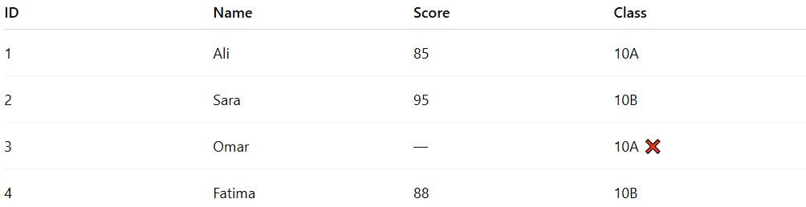
ID | Name | Score | Class
1 | Ali | 85 | 10A
2 | Sara | 95 | 10B
3 | Omar | — | 10A ❌
4 | Fatima | 88 | 10B
Replace the missing value with 0 or N/A.
After cleaning:
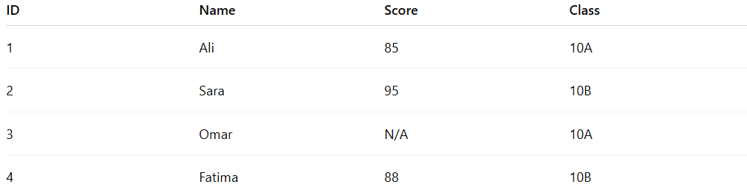
ID | Name | Score | Class
1 | Ali | 85 | 10A
2 | Sara | 95 | 10B
3 | Omar | N/A | 10A
4 | Fatima | 88 | 10B
Now the dataset contains no empty fields.

Example Section
# Source: AI Source: Provided by: [Data Path: Persons Table -> ID Column: 1, Name_En Column: Motasem Essam] -> From: [Chatgpt (GPT‑5 Mini)] on [12/10/2025]
A school database contains student records, but one student’s phone number is missing.
Before cleaning:
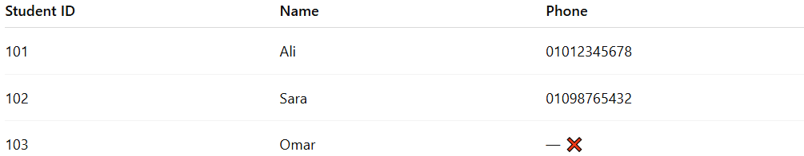
Student ID | Name | Phone
101 | Ali | 01012345678
102 | Sara | 01098765432
103 | Omar | — ❌
Cleaning process:
- Replace the missing phone number with “Unknown”.
After cleaning:
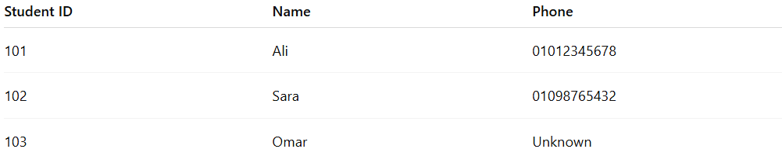
Student ID | Name | Phone
101 | Ali | 01012345678
102 | Sara | 01098765432
103 | Omar | Unknown
This ensures the dataset remains complete while indicating missing information.

Advantages
# Source: AI Source: Provided by: [Data Path: Persons Table -> ID Column: 1, Name_En Column: Motasem Essam] -> From: [Chatgpt (GPT‑5 Mini)] on [12/10/2025]
- Keeps all records in the dataset
- Simple and quick to apply
- Prevents empty or null values
- Maintains dataset structure and consistency

Disadvantages
# Source: AI Source: Provided by: [Data Path: Persons Table -> ID Column: 1, Name_En Column: Motasem Essam] -> From: [Chatgpt (GPT‑5 Mini)] on [12/10/2025]
- Default values may not represent the real data
- Can affect analysis accuracy if used excessively
- May introduce bias in statistical calculations
- Requires careful selection of appropriate default values

